

**Independent University Bangladesh**

|  |
| --- |
| **Final Report** |

***Topic - Smart Street Light***

**Course Information**

**Course Code :** CSE216L

**Course Title :** Microprocessor Lab

**Section :** 02

**Semester :** Spring 22

**Group Information**

**Group Name :** MicroBees

**Team Member1 :** Muhammad Al Asif

**Student ID :** 1820330

**Team Member2 :** Avijit Saha

**Student ID :** 1930109

**Team Member3 :** Sanjida Afrin

**Student ID :** 2020729

***Submitted To,***

Rubayed Mehedi

Lecturer,

School of Engineering, Technology & Science, IUB

***Submitted By,***

Team MicroBees

**Introduction:**

At present time we use sodium vapor light or LED light in our maximum cities as streetlight. It is seen in several cities that the streetlight is one of the huge expenses in a city. The cost spent is huge because all the sodium vapor lamps consume more power. Currently a manual system is used where the light will be made to switch ON/OFF i.e., the light will be made to switch ON in the evening and switched OFF in the morning. In fact, a lot of lamps are switched on in the morning and some of these lamps are out of service and some of the lamps remain on for a long time at night with nobody passing in the street. Hence there is a lot of wastage of energy between the ON/OFF. Also, how can we check all these lamps periodically, if a man checked these lamps each time it would be a very hard task and would have a high cost. Apart from this, the other disadvantages of the existing system are described below:

**Disadvantages of Existing System:**

* **Manual switching off/on of streetlights**: Because of the negligence of the city corporation staff in switching streetlamps off and on, **420MW** of power worth about **Tk34 lakh** is wasted every month (Dhaka Tribune, Published at 08:52 pm August 23rd, 2014).
* **More energy consumption:** A high-pressure **sodium streetlight** can draw up to **1000 watts**, and an incandescent light used in the 1900s needed 320 watts. Some **LED streetlights** require only **73 watts** and, according to the U. S. Department of Energy, produce a higher quality of light. Still now there are many streets where sodium light is used as streetlight. In the night if there are no vehicles on the road the lights are still on with full intensity which is waste of energy.
* **Hard process to find the disabled lights to repair them:** If a streetlight gets disable the authority won't be able to know it immediately (So that that part of road remains dark). They used to check the lights after a certain time. And during checking they light up all the streetlights then check them. It needs a lot of time also. Which is a hard and costly process.
* **Maintenance cost is high:** The manual system needs staff to turn on and turn off the lights. Which is very expensive. The lights are controlled manually so in the cloudy weather at the daytime the lights remain off.

**Propose your solution:**

Nowadays everything is becoming digital in the vision of digital Bangladesh. Roads are very important for any country or city. Thinking of road safety and the vision of digital Bangladesh we are proposing a system automated streetlight with the use of light sensors, not just the saving of energy and ensuring safety. Streetlight will only glow if there is darkness and someone is passing through the street. The main objective of this project is to reduce the power consumption by glowing the Street light only when it is needed. The expense spent on the streetlight can be used for other development of the nation. Our system will be able to solve the manual control system problems. Our system will be based on IoT so there are a lot of features on which we can work in future to make our system more advanced for road safety.

We can also see a few more advantages following:

**Advantages of the Proposed System:**

* **Automatic switching of streetlights:** The system will turn on the light when it will be needed (at night or at cloudy weather). So, the light will not be turned on unnecessarily.
* **Controlling the light intensity:** When it is night but there is no vehicle or object on the road then the light intensity will remain low so that we can save energy.
* **Maintenance cost reduction:** The automatic system doesn't need any staff to maintain it so the maintenance cost will become less.
* **Reduction in CO₂ emission:** It will reduce if we can control the extra waste of energy.
* **Reduction of light pollution:** It will reduce if we can control the extra waste of energy.
* **Wireless communication:** We are using IoT in our system so it will be a wireless communication. Wireless communication makes our life easy.
* **Energy saving:** It is an automated system so there will be no extra waste of energy unnecessarily.
* **Easy to find the disabled lights to repair them:** When a light doesn't work properly it sends **information (light code number) to the mentors using IoT.**

**Procedure:**

**Elaboration, steps to be done & outcomes**:

The hardware components of the system are:

1. LDR, 1Mohm (1)
2. LED (generic) (3)
3. Arduino Uno R3 (1)
4. Resistor 1k ohm (5)
5. Diligent IR Proximity Sensor (3)
6. Espressif ESP8266, ESP-12E (1)
7. Connecting wires (50 pcs)
8. Breadboard (2)
9. Adaptor ()
10. Socket ()

Software required for the programming and Online services-

1. Arduino IDE
2. ThingSpeak API
3. LDR:

A Light dependent resistor (LDR) also termed as a photoresistor is a device whose resistivity factor is a function of the electromagnetic radiation. Hence, they are light sensitive devices which are similar to that of human eyes. They are also named as photo conductors, conductive cells or simply photocells. They are made up of semiconductor materials with high resistance A LDR works on the principle of photoconductivity. Photo conductivity is an optical phenomenon in which the materials conductivity gets reduced when light is absorbed by the material. However, when light shines onto the LDR its resistance falls and current flows into the base of the first transistor and then the second transistor. The preset resistor can be turned up or down to increase or decrease resistance, in this way it can make the circuit more or less sensitive. LDR sent a response to Arduino.

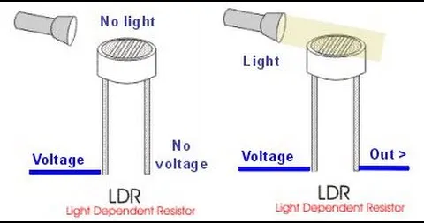

Picture: Light detection using LDR

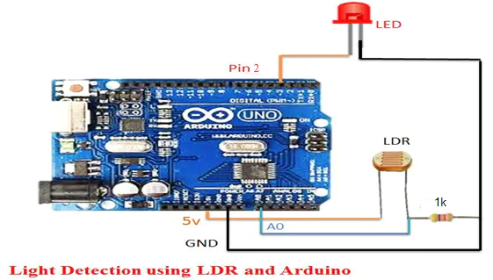

Picture: Light Detection using LDR and Arduino

* **IR Sensor:**

An Infrared sensor is an electronic instrument that is used to sense certain characteristics of its surroundings by either emitting and/or detecting infrared radiation. It is also capable of measuring heat of an object and detecting motion. Infrared waves are not visible to the human eye. In the electromagnetic spectrum, infrared radiation is the region having wavelengths longer than visible light wavelengths, but shorter than microwaves. The Infrared region is approximately demarcated from 0.75 to 1000µm. IR (infrared)sensors detect infrared light. The IR light is transformed into an electric current, and this is detected by a voltage or amperage detector. IR Sensors ends response to object and detecting motion. Infrared waves are not visible to the human eye. In the electromagnetic spectrum, infrared radiation is the region having wavelengths longer than visible light wavelengths, but shorter than microwaves. The Infrared region is approximately demarcated from 0.75 to 1000µm. IR (infrared)sensors detect infrared light. The IR light is transformed into an electric current, and this is detected by a voltage or amperage detector. IR Sensors ends response to Arduino.

Picture: Working of IR sensor

* **LED:**

Alight-emitting diode (LED) is a junction diode, which emits light when activated. When we apply voltage across its leads, electrons are able to recombine with holes within the LED, releasing energy in the form of photons which gives the light. Hence, it is a two-lead semiconductor light source.

Light emitting diodes represent our lighting system and the amount of light emitted by it is directly related to the amount of light in the environment that is when outside light is less than the light given by LEDS is at its full intensity and visa-versa.

gives the light. Hence, it is a two-lead semiconductor light source.

Light emitting diodes represent our lighting system and the amount of light emitted by it is directly related to the amount of light in the environment that is when outside light is less than the light given by LEDS is at its full intensity and visa-versa.

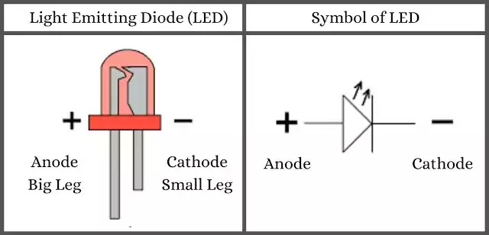

Picture: LED structure

**ESP8266-12E:**

ESP8266 is a Wi-Fi enabled system on chip (SoC) module developed by Espressif system. It is mostly used for development of IoT (Internet of Things) embedded applications.

ESP8266 comes with capabilities of

* 2.4 GHz Wi-Fi (802.11 b/g/n, supporting WPA/WPA2)
* General purpose input/output (16 GPIO)
* Inter-integrated circuit (I²C) serial communication protocol
* Analog-to-digital conversion (10-bit ADC)
* Serial peripheral interface (SPI) serial communication protocol
* I²S (inter-IC sound) interfaces with DMA (direct memory access) (sharing pins with GPIO)
* UART (on dedicated pins, plus a transmit-only UART can be enabled on GPIO2)
* Pulse-width modulation (PWM)

It employs a 32-bit RISC CPU based on the Ten silica Extensa L106 running at 80 MHz (or overclocked to 160 MHz). It has a 64 KB boot ROM, 64 KB instruction RAM and 96 KB data RAM. External flash memory can be accessed through SPI.

ESP8266 module is a low-cost standalone wireless transceiver that can be used for end-point IoT developments.

To Communicate with the ESP8266 module, the microcontroller needs to use a set of AT commands. Microcontroller communicates with ESP8266-01 module using UART having specified Baud rate.

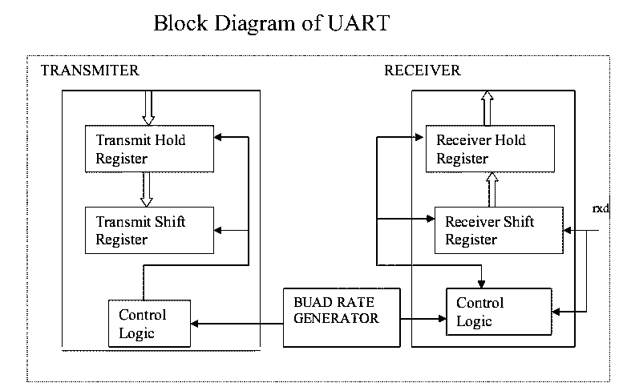

There are many third-party manufacturers that produce different modules based on this chip. So, the module comes with different pin availability options like:

* ESP-01 comes with 8 pins (2 GPIO pins) – PCB trace antenna. (Shown in above figure)
* ESP-02 comes with 8 pins, (3 GPIO pins) – U-FL antenna connector.
* ESP-03 comes with 14 pins, (7 GPIO pins) – Ceramic antenna.
* ESP-04 comes with 14 pins, (7 GPIO pins) – No ant.

etc.

For example, the figure below shows ESP-01 module pins.

**ESP8266-01 Module Pin Description**

3V3: - 3.3 V Power Pin.

GND: - Ground Pin.

RST: - Active Low Reset Pin.

EN: - Active High Enable Pin.

TX: - Serial Transmit Pin of UART.

RX: - Serial Receive Pin of UART.

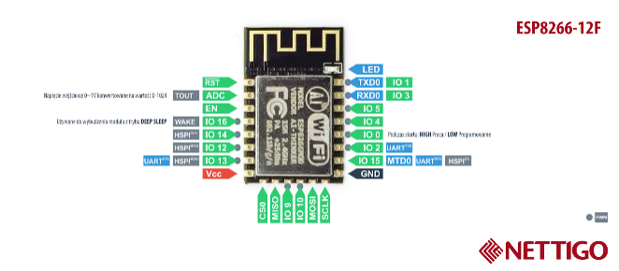

Picture: EPS8266-12E

* **Arduino Uno R3:**

Arduino Uno is a microcontroller board based on 8-bit ATmega328P microcontroller. Along with ATmega328P, it consists of other components such as crystal oscillator, serial communication, voltage regulator, etc. to support the microcontroller. Arduino Uno has 14 digital input/output pins (out of which 6 can be used as PWM outputs), 6 analog input pins, a USB connection, A Power barrel jack, an ICSP header ATmega328P, it consists of other components such as crystal oscillator, serial communication, voltage regulator, etc. to support the microcontroller. Arduino Uno has 14 digital input/output pins (out of which 6 can be used as PWM outputs), 6 analog input pins, a USB connection, A Power barrel jack, an ICSP header and a reset button.

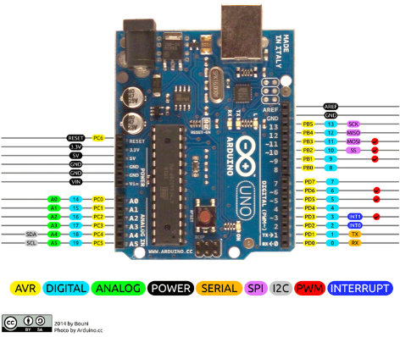

Picture: Arduino Uno R3

Pin Description

Arduino Uno Technical Specifications

|  |  |
| --- | --- |
| Microcontroller | [ATmega328P](https://components101.com/microcontrollers/atmega328p-pinout-features-datasheet) – 8 bit AVR family microcontroller |
| Operating Voltage | 5V |
| Recommended Input Voltage | 7-12V |
| Input Voltage Limits | 6-20V |
| Analog Input Pins | 6 (A0 – A5) |
| Digital I/O Pins | 14 (Out of which 6 provide PWM output) |
| DC Current on I/O Pins | 40 mA |
| DC Current on 3.3V Pin | 50 mA |
| Flash Memory | 32 KB (0.5 KB is used for Bootloader) |
| SRAM | 2 KB |
| EEPROM | 1 KB |
| Frequency (Clock Speed) | 16 MHz |

* **Bread Board:**

A breadboard is a rectangular board with many mounting holes. They are used for creating electrical connections between electronic components and single board computers or microcontrollers﻿ such as Arduino and Raspberry Pi. The connections aren't permanent, and they can be removed and placed again.

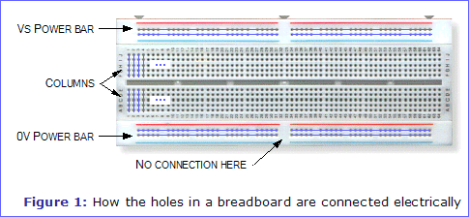

* **Connecting wire:**

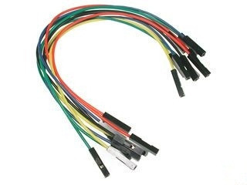

Connecting wires allows an electrical current to travel from one point on a circuit to another because electricity needs a medium through which it can move. Most of the connecting wires are made up of copper or aluminum.

There are 3 types of connecting wire:

1. Male to Male
2. Male to Female
3. Female to Female

* **Resistor:**

A resistor reduces (or resists) the flow of current. So, a 1k Ω resistor has a value of 1,000 ohms and the number we will code is 1,000.

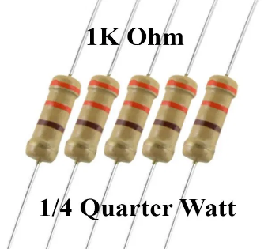

Picture: Resistor

**Apps and Online services:**

1. Arduino IDE 1.8.13:  The open-source Arduino Software (IDE) makes it easy to write code and upload it to the board. This software can be used with any Arduino board. [Download Link](https://www.arduino.cc/en/software)
2. Think Speak API: Thing Speak is an open source “Internet of Things” application and API to store and retrieve data from things using HTTP over the Internet or via a Local Area Network. With Thing Speak, you can create sensor logging applications, location tracking applications, and a social network of things with status updates. The Thing Speak application also features time zone management, read/write API key management and JavaScript-based charts from High slide Software / Torstein Hønsi. Support for Thing Speak is available on the [ThingSpeak Community](http://community.thingspeak.com/) site which features a [Blog](http://community.thingspeak.com/), [Forum](http://community.thingspeak.com/forum/), [Documentation](https://thingspeak.com/docs), and

[Tutorials](https://thingspeak.com/docs/tutorials/). [How to work with it!](https://github.com/iobridge/ThingSpeak)

**Results:**

**How will our system work?**

* LDR will send a response to the Arduino by sensing light from the outside environment.
* When it is dark outside the LDR will send a signal to the Arduino.
* At daylight LDR will not send any signal to Arduino.
* The IR sensor will sense the vehicle on the road.
* If there is any vehicle the sensor will send a signal to the Arduino

Otherwise, it will remain in the same condition.

* Arduino will work on these responses through its code and it will send a signal to the LED, how the light will be lightened. Arduino will control the power that passes through the LED according to its code condition.

Other hand the ESP8266 which is also connected with the Arduino will transmit the data which is taken from the Arduino by analyzing the data sensed by the sensor to the Thing Speak online service. And through Thing Speak API we can control the system because ESP8266 can also send a command to Arduino and execute it.

**Discussion:**

1. The most challenging part is that all the team members are not able to do this project together directly, hence knowledge sharing between the members are minimal.

2. The members are not familiar with the use and applications of Arduino Uno R3 as a result there is some time loss, in the process of becoming familiar with its use.

**Conclusion:**

With a capability to change the amount of light emitted depending upon the external environment it will be an innovation with many future applications. The usage of the smart lighting system will help us innovate the road sector conditions**.**

**Reference:**

1. [IoT-based dynamic street light control for smart cities use cases | IEEE Conference Publication | IEEE Xplore](https://ieeexplore.ieee.org/document/7746112)
2. [Internet of things - Wikipedia](https://en.wikipedia.org/wiki/Internet_of_things)
3. [Iot based smart and adaptive lighting in street lights | IEEE Conference Publication | IEEE Xplore](https://ieeexplore.ieee.org/document/7972267)
4. [Smart street lights using IoT | IEEE Conference Publication | IEEE Xplore](https://ieeexplore.ieee.org/abstract/document/8389119)
5. [Smart Street Lights | IEEE Conference Publication | IEEE Xplore](https://ieeexplore.ieee.org/document/6757123/authors#authors)